Project Planning Phase

# Project Planning Template (Product Backlog, Sprint Planning, Stories, Story points)

|  |  |
| --- | --- |
| Date | 22 October 2022 |
| Team ID | PNT2022TMID31896 |
| Project Name | Global Sales Data Analytics |
| Maximum Marks | 8 Marks |

## Product Backlog, Sprint Schedule, and Estimation (4 Marks)

Use the below template to create product backlog and sprint schedule

|  |  |  |  |  |  |  |
| --- | --- | --- | --- | --- | --- | --- |
| **Sprint** | **Functional**  **Requirement (Epic)** | **User Story**  **Number** | **User Story / Task** | **Story Points** | **Priority** | **Team**  **Members** |
| Sprint-1 | Registration | USN-1 | user can register for the application by  entering my email and password | 3 | High | VISHNU KURUP |
| Sprint-1 |  | USN-2 | User will receive email if the registration is successful. That the registration has  conformed | 3 | High | VISHNU SURYA P |
| Sprint-1 |  | USN-3 | As a user, I can register by any browser. | 5 | Low | TAMILSELVAN S |
| Sprint-1 |  | USN-4 | As a user, I can extract data | 3 | Medium | JAGATHESH S |
| Sprint-1 | Login | USN-5 | As a user, I can log into the application by entering email & password | 6 | High | VISHNU S |
| Sprint-2 | Dashboard | USN-6 | I can access the dashboard of mine. | 3 | Medium | JAGATHESH S |
| Sprint-2 |  | USN-7 | I can register for the application through any web browser. | 5 | Low | VISHNU SURYA P |
| Sprint-2 |  | USN-8 | I can use my credentials. For accessing my resources. | 2 | High | VISHNU S |
| Sprint-2 |  | USN-9 | As, a user I can schedule events and set events. | 7 | High | VISHNU KURUP |
| Sprint-3 | Support | USN-10 | I can perform analysis by tools (IBM Cognos) | 10 | Medium | TAMILSELVAN S |
| Sprint-3 |  | USN-11 | Responds to user queries via telephone, email etc. | 3 | Medium | VISHNU SURYA P |
| Sprint-3 |  | USN-12 | The team must respond immediately to the queries based on the priority | 5 | High | TAMILSELVAN S |
| Sprint-4 | System Requirements | USN-13 | Hardware Requirement   1. Laptop or PC    * i5 processor system or higher    * 4 GB RAM or higher    * 128 GB ROM or higher 2. Mobile   (12.0 and above) | 5 | Low | VISHNU KURUP |
| Sprint-4 |  | USN-14 | Software Requirement   1. Laptop or PC    * Windows 10 or higher   Android Studio | 8 | Medium | VISHNU SURYA P |

## Project Tracker, Velocity & Burndown Chart: (4 Marks)

|  |  |  |  |  |  |  |
| --- | --- | --- | --- | --- | --- | --- |
| **Sprint** | **Total Story Points** | **Duration** | **Sprint Start Date** | **Sprint End Date (Planned)** | **Story Points**  **Completed (as on Planned End Date)** | **Sprint Release Date (Actual)** |
| Sprint-1 | 20 | 6 Days | 24 Oct 2022 | 29 Oct 2022 | 20 | 29 Oct 2022 |
| Sprint-2 | 20 | 6 Days | 31 Oct 2022 | 05 Nov 2022 | 17 | 05 Nov 2022 |
| Sprint-3 | 20 | 6 Days | 07 Nov 2022 | 12 Nov 2022 | 18 | 12 Nov 2022 |
| Sprint-4 | 20 | 6 Days | 14 Nov 2022 | 19 Nov 2022 | 13 | 19 Nov 2022 |

**Velocity:**

Imagine we have a 10-day sprint duration, and the velocity of the team is 20 (points per sprint). Let’s calculate the team’s average velocity (AV) per iteration unit (story points per day)

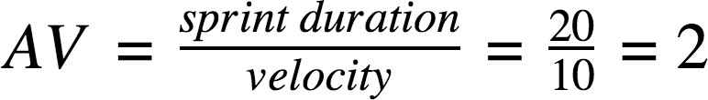

**Burndown Chart:**

A burn down chart is a graphical representation of work left to do versus time. It is often used in agile software development methodologies such as Scrum. However, burn down charts can be applied to any project containing measurable progress over time.

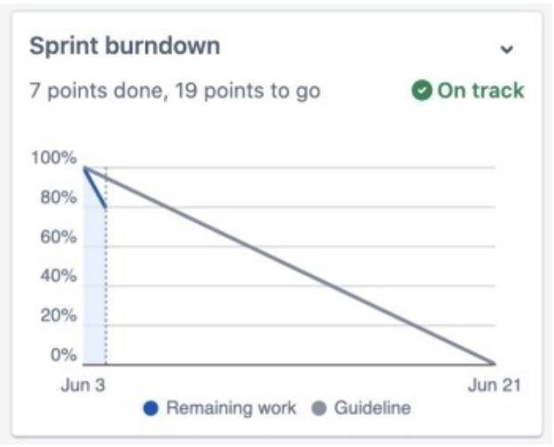

# To view the epic burndown chart:

1.Navigate to your scrum project.

2.Select the Backlog.

1. Click Reports, then select Epic Burndown.
2. Select an epic from the dropdown next to the Epic Burndown header.

You'll be able to choose from epics that are in projects configured for your board, via the board's filter.

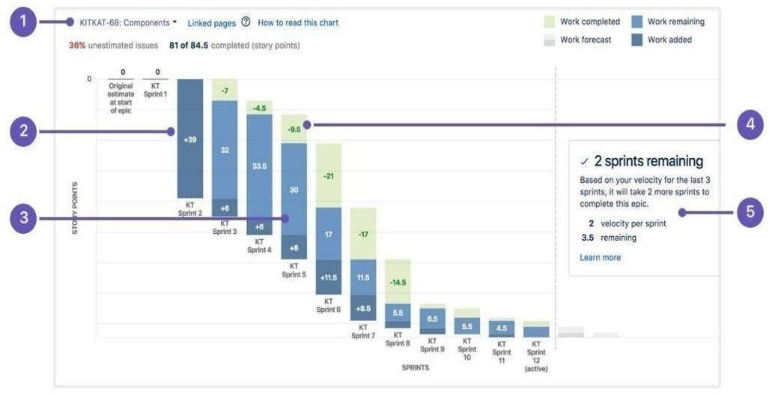

1. **Epic menu:** Select which epic to view data for.
2. **Work added:** The dark blue segment shows the amount of work added to the epic in each sprint. In this example, work is measured story points.
3. **Work remaining:** The light blue segment shows the amount of work remaining in the epic.
4. **Work completed:** The green segment represents how much work is completed for the epic in each sprint.
5. **Projected completion:** The report projects how many sprints it will take to complete the epic, based on the team's velocit